Lab 9
Task 1
START TRANSACTION;

DELETE FROM baggage WHERE booking_id = 50;
DELETE FROM baggage_check WHERE booking_id = 50;
DELETE FROM boarding_pass WHERE booking_id = 50;
DELETE FROM booking_flight WHERE booking_id = 50;

DELETE FROM booking WHERE booking_id = 50;

COMMIT;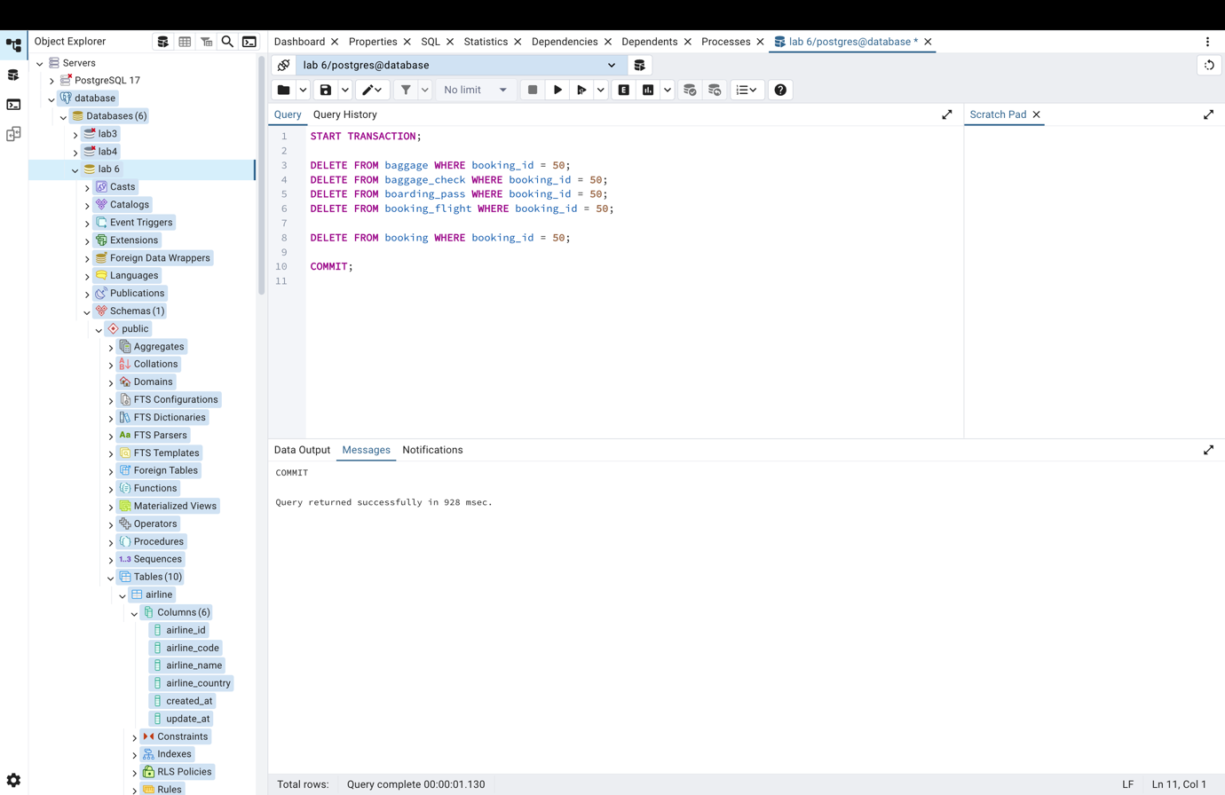
Task 2
BEGIN;
UPDATE flights
SET scheduled_departure = '2026-01-05'
WHERE flight_id = 200;
COMMIT;
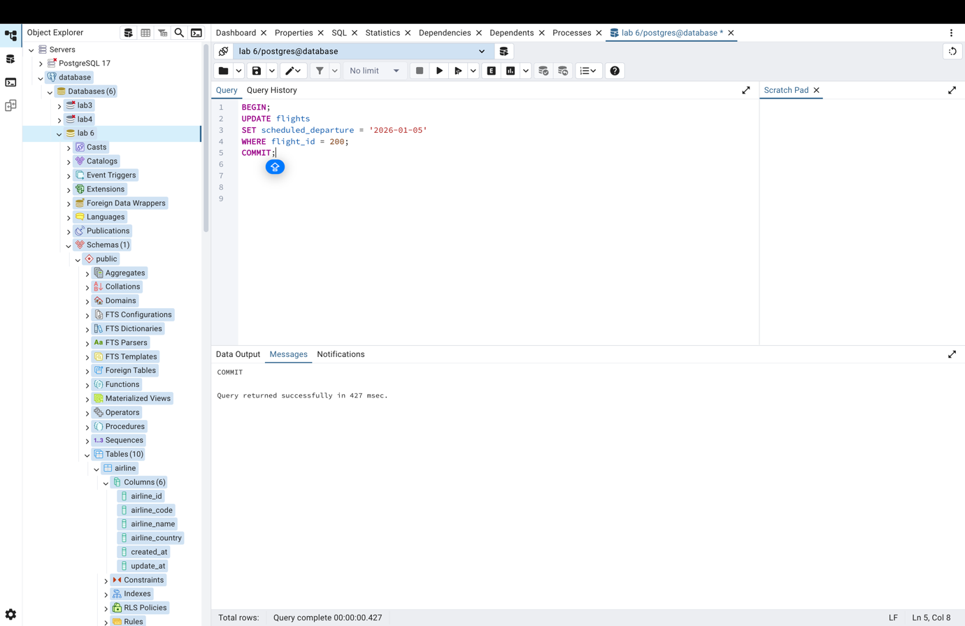
Task 3
BEGIN;

UPDATE booking
SET price = price - 5000
WHERE booking_id IN (
SELECT booking_id FROM booking_flight WHERE flight_id = 10
);

COMMIT;

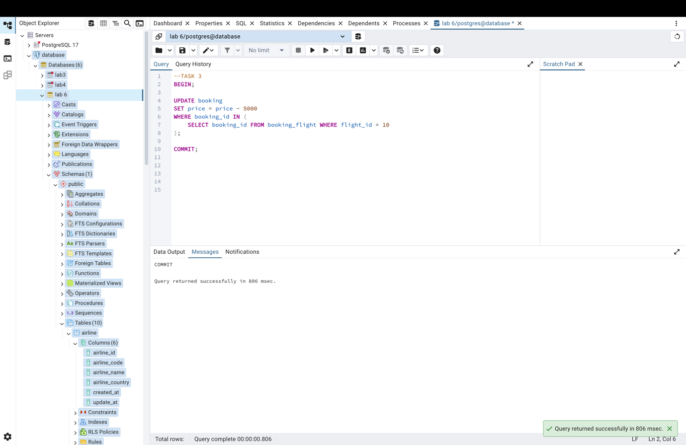
Task 4
BEGIN;

UPDATE passengers
SET first_name = 'Dana',
last_name = 'Serik',
country_of_residence = 'Kazakhstan',
update_at = CURRENT_DATE
WHERE passenger_id = 20;

COMMIT;
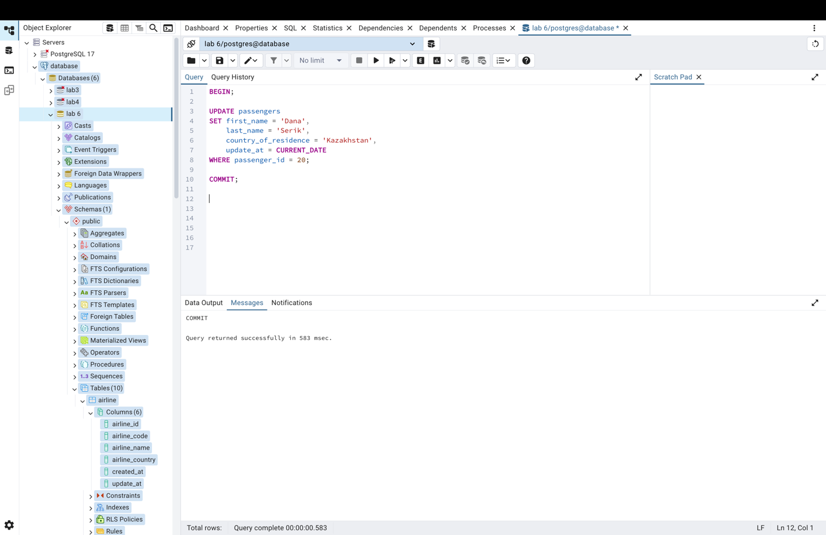

Task 6
BEGIN;

UPDATE booking
SET price = price + 3000
WHERE booking_id IN (
SELECT booking_id FROM booking_flight WHERE flight_id = 22
);

COMMIT;
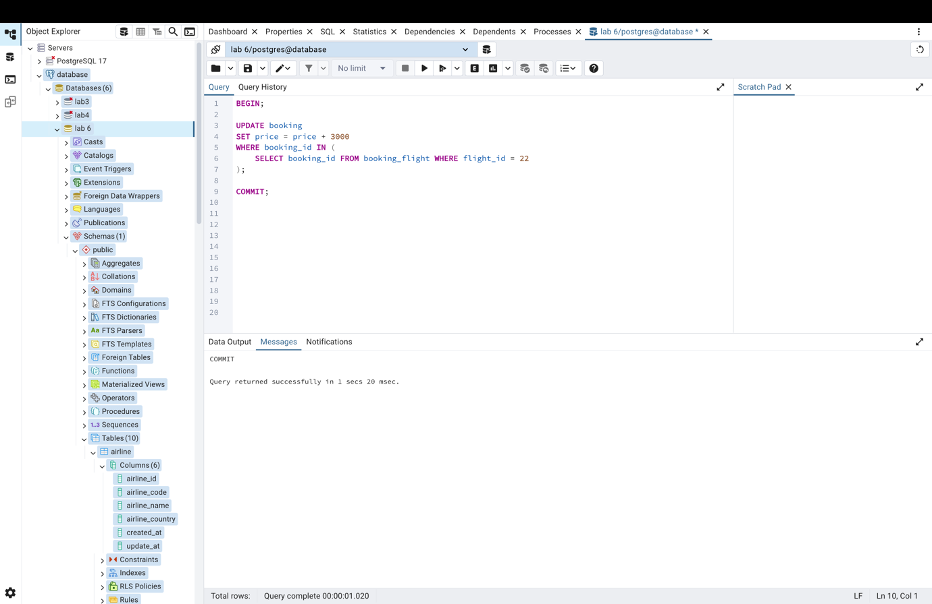
Task 7
BEGIN;

UPDATE baggage
SET weight_in_kg = 27.5, update_date = CURRENT_DATE
WHERE baggage_id = 300;

COMMIT;
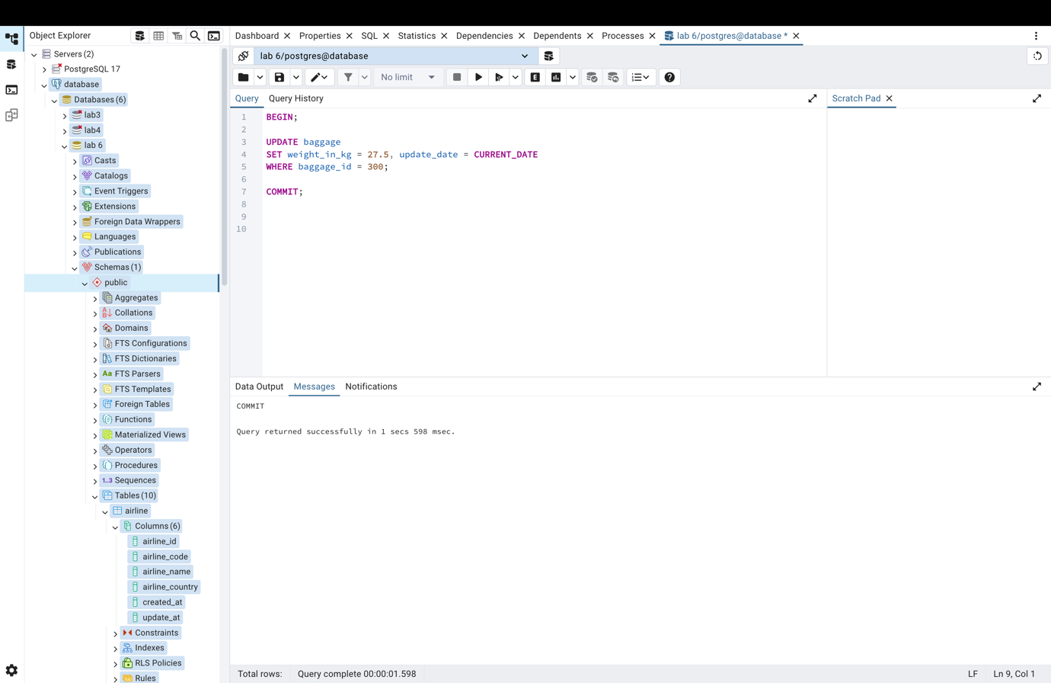
Task 8
BEGIN;

UPDATE booking
SET price = price * 0.9
WHERE booking_id = 150;

COMMIT;
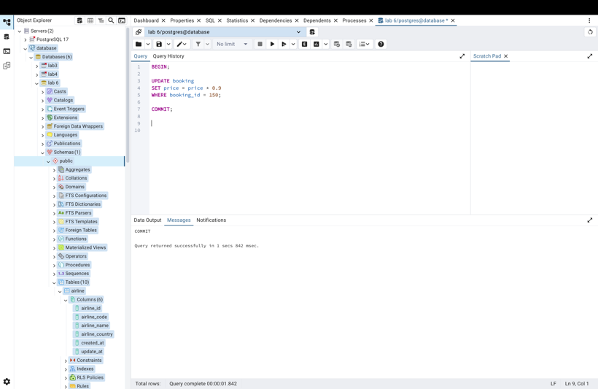
Task 9
BEGIN;

UPDATE booking_flight
SET flight_id = 99
WHERE flight_id = 50;

COMMIT;
